Saint Luke Health Ministry
Evening Programs
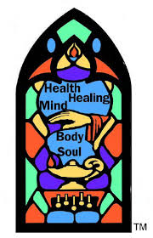

Good Grief — Losing & Finding

How losing someone we love affects our lives
Choices/practices to help us live well as we move forward

Presented by two experienced grief counselors
with time for questions:

Ann Hisle LCSW-C, current grief counselor; formerly with Montgomery Hospice

Judy Taibl, 25 yr. grief counselor, Annandale, VA

Wednesday
November 16, 2016
7:00 — 9:00 PM
Flaherty Hall

Printed resources & brochures available, including the book
My House Burned & Now I Can See the Stars, by Ann Hisle

(If you wish to attend and need a ride,
please contact Mary Jo Frickel, 703-402-9648)

