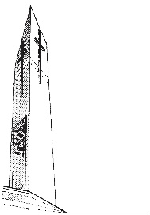
Saint Luke Catholic Church
7001 Georgetown Pike
McLean, Virginia 22101

SPONSOR/GODPARENT CERTIFICATE FOR THE SACRAMENT OF BAPTISM

Please complete the top portion of this form and contact the parish office (703.356.1255) to obtain the Pastor’s signature and parish seal.

I, ____________________________________________, a registered member of ___________________________________________________, accept the invitation to be a Godparent for the Baptism of _________________________________________.

I hereby affirm that: (please initial)
_____ I am at least 16 years old.
_____ I have received the sacraments of Baptism, Holy Eucharist and Confirmation myself.
_____ If married, I was married in the Catholic Church.
_____ I am a practicing Catholic, faithfully attending Mass on Sundays and Holy Days of
Obligation and leading a life based on Catholic Moral Principles.

_________________________________________ ____________________
Sponsor/Godparent Signature Date

Witnessed By:

___________________________________________ _____________________
Signature of Priest Date

PARISH SEAL
(must be present)

